The Brinson Foundation does not accept unsolicited grant applications.
If you have not already done so, please review our Inquiries page for information about how to submit a preliminary inquiry. You must submit your inquiry using our Grantseeker Information Form. We accept inquiries throughout the year.
If our initial review of a grantseeker inquiry indicates there may be a sufficient priority and focus area match, we will assign one of our program officers to communicate with the grantseeker to learn more about the organization and its programs. If a grantseeker remains under consideration, our spring and fall due diligence, application and grantmaking cycles proceed as follows:
For New Grantseekers: We generally conduct due diligence discussions with grantseekers that are being considered for spring cycle invitations between January and March.
Following these due diligence discussions, the staff determines whether to invite the grantseeker to submit a grant application. If so, we email the grantseeker a formal application invitation. Spring cycle applications are generally due on the last business day in February.
The staff reviews all applications and prepares recommendations for our Board of Directors. The Board meeting usually occurs in late April or early May. Following the Board meeting, we contact each applicant and advise them of the Board’s decision. If the grant is approved, we generally send out the grant agreement within two weeks following the Board meeting and disburse the grant upon receipt of the signed agreement.
The fall cycle activities are the same as the spring cycle but they begin between July and September and end in November or December.
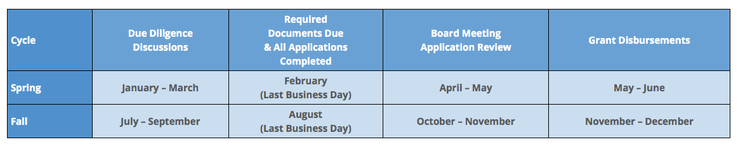
For Current Grantees: We have adopted a simplified renewal process for current grantees which combines the evaluation questionnaire and renewal application. The process generally follows the cycle calendars shown above.

