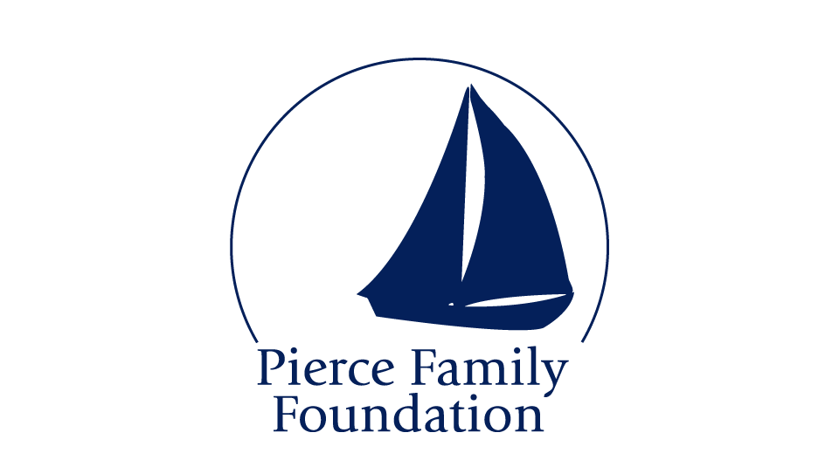
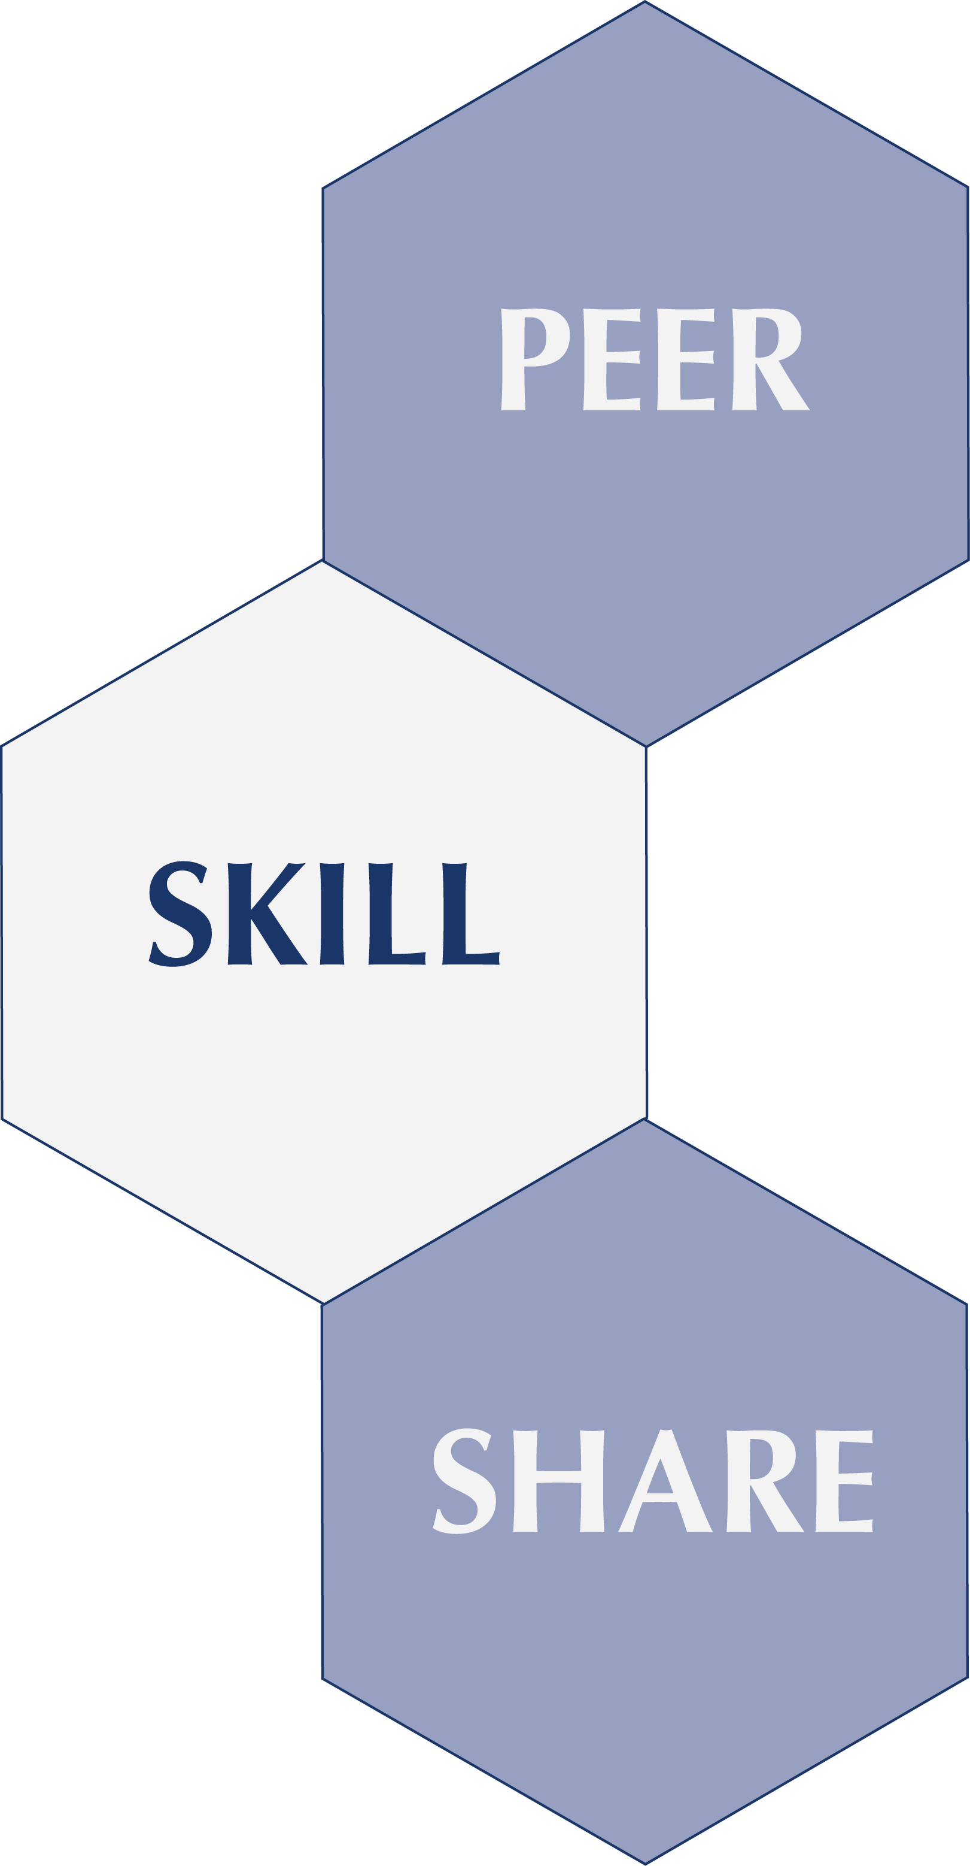

A Program of the
Pierce Family Foundation

Overview

The Peer Skill Share program is designed to invest in the professional skills of nonprofit employees, building their individual capacity and by extension, the capacity of their organizations. The Pierce Family Foundation arranges for nonprofit employees to help each other via “skill share” sessions, where grantees can get one-on-one advice from peers on specific needs they identify. Since there is time involved on both sides, a $200 micro-grant is offered to both the trainer’s and the trainee’s organization after their session is complete.

Twice each year, the Foundation invites grantees (its own and those of foundation partners) to an online portal and asks them to name 2-3 things they want advice on, and 2-3 areas in which they have expertise that they would enjoy sharing. Agencies do not have to offer something themselves in order to request a colleague's help.

Foundation staff reviews the responses and makes matches. Once matched, it is up to the grantees to arrange their meetings, which usually last a couple of hours.

Pierce Family Foundation launched Peer Skill Share with a small pilot program among its grantees in the fall of 2010. Since then, the program has added foundation partners and run Skill Share “rounds” five times—with more than 200 matches made to date, involving agencies ranging from the Lyric Opera to Casa Central.

Foundation Partners

Grantees of the Pierce Family Foundation and grantees of any participating foundation partners are invited, via our online portal. Foundation partners thus far for 2014 are:
AIDS Foundation of Chicago, Arts Work Fund, Chicago Foundation for Women, Advocate Bethany Community Health Fund, Brinson Foundation, Oak Park River Forest Community Foundation, Prince Charitable Trusts, Alphawood Foundation, Siragusa Foundation, Lawyers Lend a Hand, Crossroads Fund, McDougal Family Foundation.

A Few SAMPLE Matches from Past Rounds

Subject Area: Administration/Operations (5% of matches)
Session Focus | Trainer Organization | Matched with
Succession planning for senior staff | Changing Worlds, Remy Bumppo Theatre | Deborah's Place
Organization-wide management dashboards | Mercy Housing Lakefront | Changing Worlds

Subject Area: Finance (10% of matches)
Session Focus | Trainer Organization | Matched with
Salesforce.com software help | Center for Economic Progress | Moran Center
Bookkeeping schedule for a temp, how to make it work | EdgeAlliance | Sones de Mexico Ensemble
Bookkeeping, part 2 | EdgeAlliance | Sones de Mexico Ensemble
Getting better at negotiating contracts with the city | Housing Opportunities for Women | Institute for Women Today
Quickbooks software | Project Exploration | Moran Center, Chicago Legal Advocacy for Incarcerated Mothers
Quickbooks software | Street Level Youth Media | Chicago Religious Leadership Network

Subject Area: Program Delivery (15% of matches)
 | Trainer Organization | Matched with
Transgender cultural competency training | AIDS Foundation of Chicago | Chicago House
Incorporating research into everyday operations | Associated Colleges of Illinois | Northshore Concert Band
Financial literacy/economic advancement tools for clients | Center for Economic Progress | Chicago House
Harm reduction philosophy of program delivery | Deborah's Place | Inner Voice
LGBTQ inclusion and cultural competency | La Casa Norte | Renaissance Social Services
Improving support given to clients when legal issues may be involved | La Casa Norte | Cabrini Green Legal Aid
Best practices in public speaking | Project Exploration | The Cara Program
Working with youth (best practices) | Teen Living Program | We the People Media
Employment workshop how-to/ curriculum development | The Cara Program | Housing Opportunities for Women, The Renaissance Collaborative

ETC.

What Participants Are Saying

“This support for learning opportunities is a lifeline. Through Peer Skill Shares we learn new skills and have an opportunity to explore collaboration.”

“The skill shares have been so valuable in their own right, I completely forget about the micro-grant part of it all.”

“Knowing now the value of what [my Skill Share partner] had to share with me, I would have gladly paid top dollar for an hour and a half of her time.”

“It was a great session that helped affirm the direction I would like our agency to follow.”

“Our meeting was very productive and fruitful, and we have gained important knowledge toward creating a successful development plan.”

“I appreciated the opportunity to get to know an organization I was not familiar with and brainstorm how we could collaborate to better serve.”

“We went over sponsorship and promotion ideas, and have since developed and begun to distribute our sponsorship packet. We feel that we now have a much clearer direction for the event and a wide variety of ideas for ways to reach our revenue goal.”

“The knowledge and skills we gained from this session have shed light on the different ways we can better use Salesforce in our daily operations to save time and build the infrastructure to support a more sophisticated strategy for donor communications.”

“This is our first Peer Skill Share meeting, and I can honestly say that it really proved to support the mission of the grantees, by successfully bringing together artists that would not normally have crossed paths.”

“On November 29, when we met [for a Peer Skill Share session on Facebook strategies], our latest Facebook post had reached 171 people. Today, our latest post reached 1,888.”

“Thanks to the media expertise [of our Peer Skill Share partner], we were recently featured in the Sun Times.”

“As a result of this session, our staff’s understanding and tolerance around trans-specific issues has greatly increased, and this increased awareness and education can be felt throughout the agency.”

RESPONSE TO FEBRUARY 2014 SURVEY of PSS PARTICIPANTS

Matches have often been between organizations that might otherwise not cross paths, which is one of the program's great assets. Via100 respondents (25% response rate), the following was reported:

- 92% gave their experience a grade of “excellent” or “good.”

- 76% rated what they learned as “excellent” or “good.”

- 86% are using the knowledge they gained.

- 89% said the session has helped their organizations because they’ve shared what they learned with others, or it’s directly improved departmental results, efficiency, etc.

- 51% report keeping in touch with their ‘match’ and following up on their own via subsequent calls, meetings, emails, etc.

Sample Report from Session Participants

Center for Economic Progress & JJ’s List
Match Topic: Issues in Volunteer Management
(Trainer's Report)
On Friday, I (Angela Perkins, CEP) met with JJ, Shuling, Sarah, Jake, and Alexa from JJ's List. Using CEP's volunteer job descriptions and outreach materials, as well as an outside article, I addressed JJ's question about how specific should they be in volunteer job descriptions. This led to some important questions about how they should incorporate volunteers with disabilities (some of whom were present for the conversation). We explored some of the challenges of their current system, in which volunteers are invited to stop by any time they have free time, and discussed possible ways to revamp that system to fit their support base while also building in some limits that would facilitate staff productivity, such as set hours for volunteer projects and identification of a few ongoing needs that would fill volunteer time on a regular basis. The team had some concerns about how much effort they should put into engaging volunteers as it seemed to be impeding productivity, and we discussed whether or not they felt it was mission-critical to offer volunteer opportunities with high levels of flexibility. The team will consider that as they decide how to proceed.
We also discussed how to use volunteers in planning fundraisers. In the past, JJ's friends have taken on the responsibilities, and they are looking to transfer that work to other volunteers. This year, they will pair experienced volunteers from previous years with some of their volunteers with disabilities. Each pair will have responsibility for one aspect of the event to ensure accountability. I shared my insights from working with CEP's Associate Board to plan fundraisers.

(Trainee’s Report)
The JJ's List team met with Angela Perkins from the Center for Economic Progress on Friday to learn about volunteer management at our organization.
As someone who works with over 1000 volunteers every year, Angela gave us some good insights into things like how to recruit volunteers, the training process their volunteers go through, volunteer motivations, providing volunteer incentives, and managing task completion and schedules. She also brought along several copies of their volunteer recruitment flyer and their PowerPoint slides used for volunteer recruitment for us to keep. JJ's List brought 3 people from our office, and 2 of our regular volunteers to learn at the session, and we look forward to implementing our newfound knowledge. What a great experience.

LOGISTICS for Funder Partners

Matches are made via an online questionnaire process which Pierce manages; funder partners have no administrative workload other than sharing grantee contact emails with the Peer Skill Share Coordinator.

Should you want to offer PEER SKILL SHARE to your grantees in the next round -- you don't have to actually do anything other than let your grantees know that they will be invited to participate, and that they will hear from us. (We supply a template for you to use to alert them). You then give us the email contacts of those you'd like invited.

At the start of each round, Pierce will request that contact info from you, via our Peer Skill Share Coordinator, Randy Baker.

We then contact all grantees that all funders want to invite, vie an email that gives your grantees access to the Peer Skill Share portal. All communications and record-keeping is managed via our Peer Skill Share portal. Once grantee match sessions are complete, participants enter a brief report back into the portal to get their $200 microgrant. Reports are shared at the end of each cycle with funders.

Currently, Foundations partners only pay the $200 micro-grant for whichever of their grantees end up participating. (In the future, there might also be a modest fee to help spread the operational costs, but not currently.)

In terms of payout logistics, you'd have three options:

1. Pierce can pay the micro-grants as we go along, and then "invoice" you for reimbursement at the end of the cycle. Doing it this way however--- one foundation making a payment to another-- means that these expenses would not count as 'grants' for you, but as a program expense.
2. We could send you a monthly list of grantees who complete their sessions, and you pay the micro-grants directly to each of your grantee agencies, as we go along.
3. We send you one grand list at the end of the cycle, and you pay the micro-grants directly, all at once, for your grantee agencies.

For your budget purposes, although participation varies, generally speaking we’ve found that not more than 15% of submitted contact names end up participating.

For example, Prince Trusts submitted 52 names, and had eight grantees participate.
Alphawood submitted 151 names, and had 11 agencies participate. We’ve also discovered that grantee participation levels are greatly influenced by how much promotion or even mention of the opportunity is done by the sponsoring foundation.

Pierce grantees are very familiar with it, so participate at high levels. Arts Work Fund grantees have also heard about it for a few rounds now, and participate at high levels.

