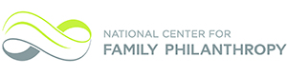

**Community Foundation Business Models for Family Philanthropy**

**CF Spark Session Webinar**

**Featured Speakers**

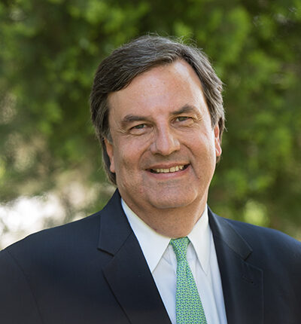**Bob Fockler is President of the Community Foundation of Greater Memphis, a public foundation which annually assists individuals, families and corporations in making their charitable giving simpler and more powerful. Through the generosity of its donors, the Community Foundation last year granted $163 million to almost 1,900 nonprofit organizations in the Mid-South and throughout the nation. Bob brings to the Community Foundation the financial and managerial expertise gained from a 24-year career in investment banking and organizational experience gained from an equally long record of service in the nonprofit world. Bob holds a bachelor’s degree in history from Princeton University.**

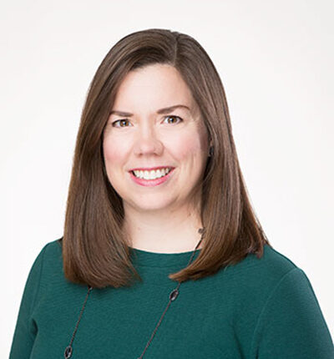**Whitney Hosty** is a senior philanthropic advisor for the Greater Kansas City Community Foundation, a leading provider of charitable giving services. With an asset base of more than $3 billion, the Community Foundation has ranked among the top one percent of community foundations in the country since 1999.

Whitney oversees the Community Foundation’s donor education program and works closely with families and private foundations to focus and guide their philanthropic investments. Whitney has earned the Chartered Advisor in Philanthropy® certification, completed 21/64 training and the Kansas City Tomorrow civic engagement program to better serve the donors she works with.

Whitney earned her bachelors of arts in French studies and a concentration in leadership studies from Williams College in Williamstown, Mass. Whitney currently serves on the Board of Trustees at St. Paul’s Episcopal Day School and is president of the Williams College Regional Alumni Association.

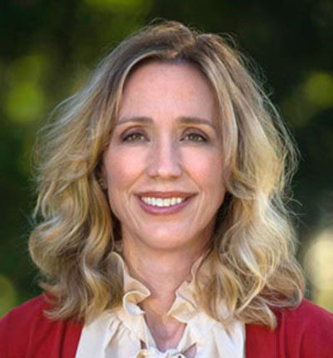

**Caroline Kuebler** is the Director of Development at the Community Foundation of Greater Memphis, the largest charitable grant-maker in the Mid-South with grants of more than $163 million last year. The Community Foundation’s mission is to strengthen the community through philanthropy by managing charitable funds, addressing the needs of the community and encouraging the growth of charitable resources. In her role as a family philanthropy advisor, Caroline fosters philanthropic engagement by working with individuals to be more intentional in their giving.

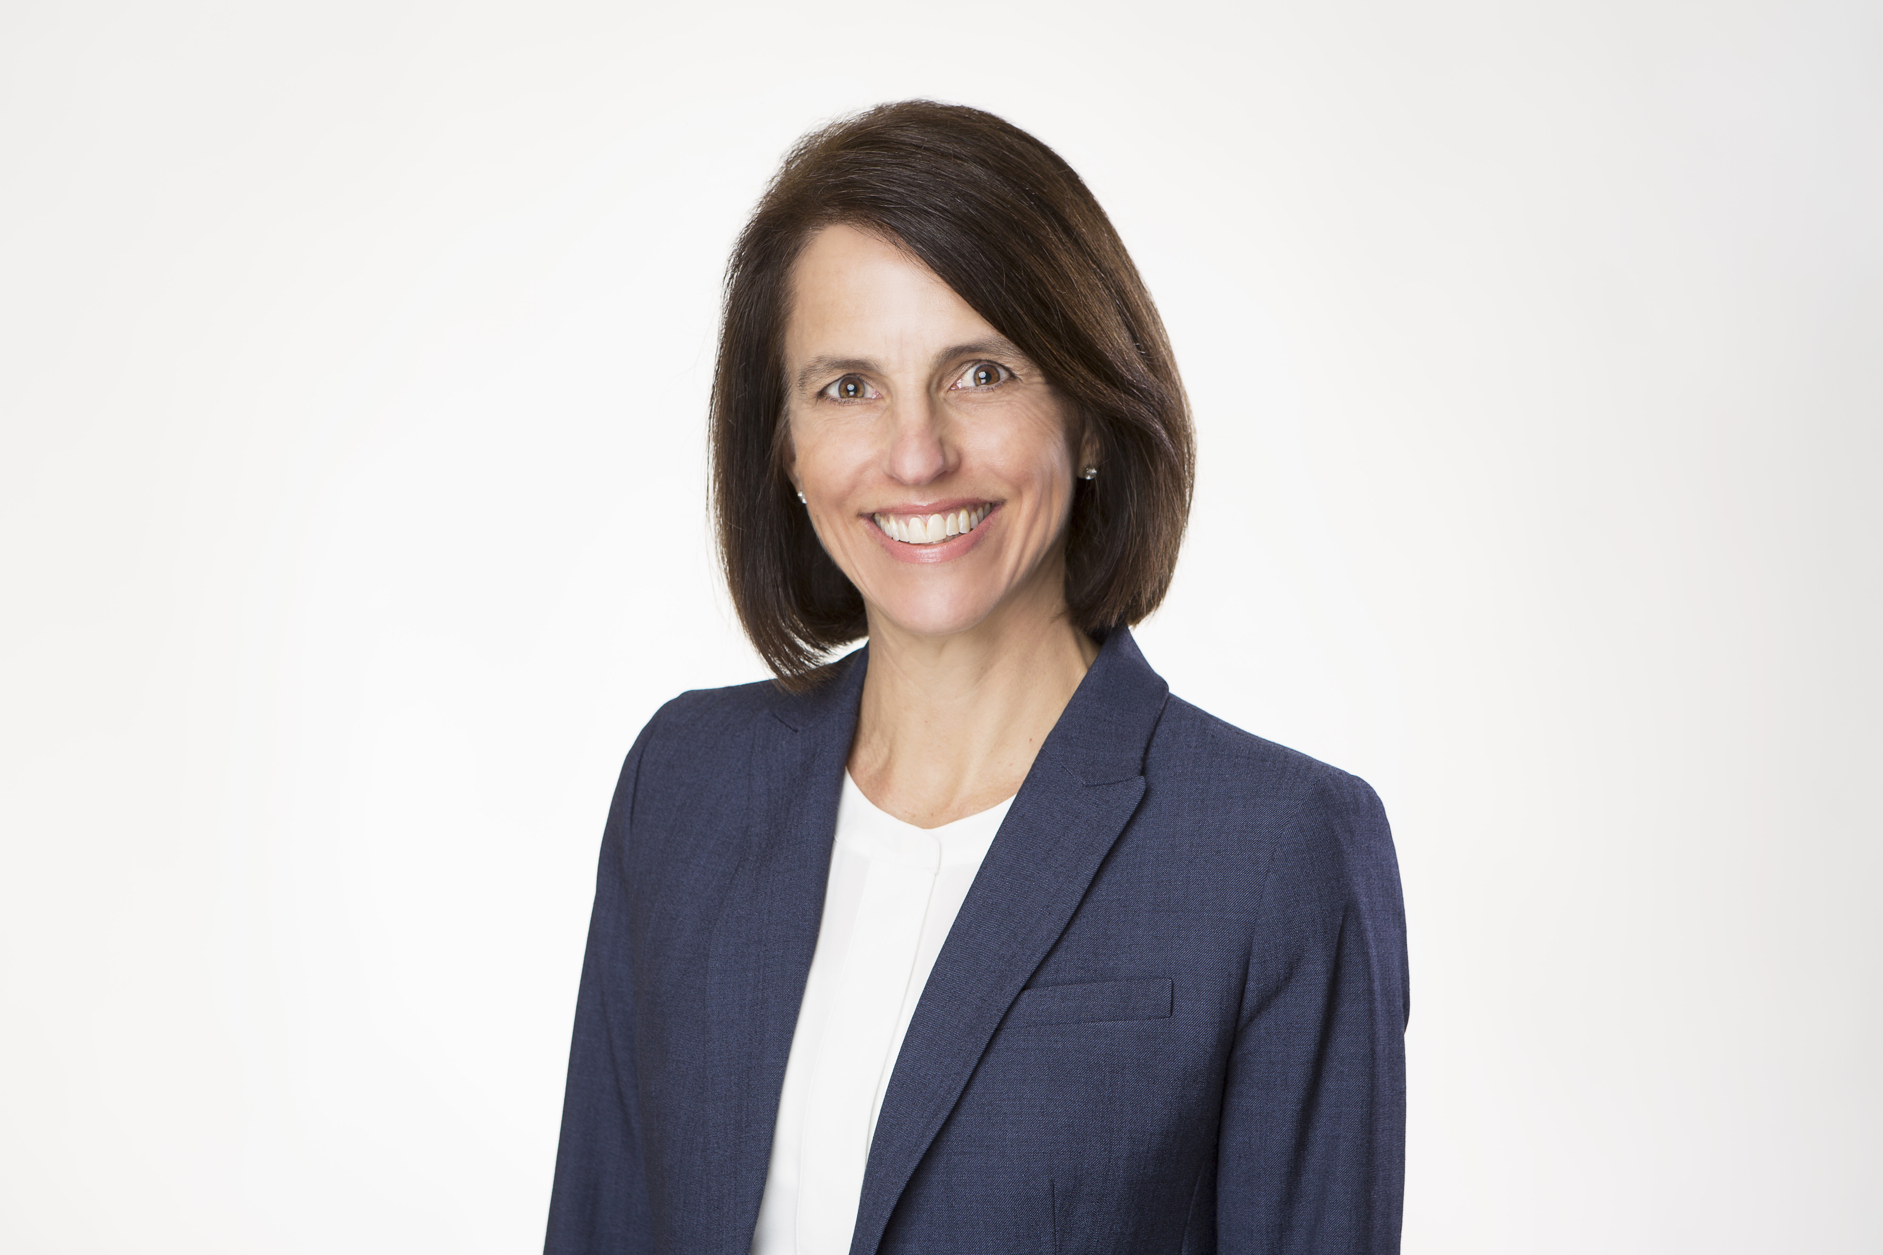**Debbie Wilkerson** is the President and CEO of the Greater Kansas City Community Foundation. As the leader of the Greater Kansas City Community Foundation and Greater Horizons, Debbie Wilkerson’s job is to make it easy for individuals, families and companies to establish charitable funds and give to the causes they care about.

Debbie oversees a team that empowers donors by providing a comprehensive platform of charitable tools and an exceptional giving experience.

Debbie earned both her undergraduate and law degrees from the University of Kansas. Prior to joining our team in 1998, Debbie was an attorney, focusing on tax and estate planning. Debbie served in a variety of roles, including general counsel and COO, before assuming the role of President & CEO in 2012.